

Innovative Technology Limited

Smiley Bank Note Validator
NV2/3

Technical Manual

© Innovative Technology Limited 1996. No part of this document may be reproduced without the prior written permission of Innovative Technology Ltd.

Innovative Technology has a policy of continuous improvement and reserves the right to amend this specification without prior notice

Innovative Technology Germany:
Automated Transactions (ITL) GmbH, Osterholder Allee 2, 25421 Pinneberg, Germany.
Tel +49 (0)4101 370 99 00 Fax +49 (0)4101 370 99 00
www.automated-transactions.de info@automated-transactions.de

Innovative Technology Ltd, Milton Street, Royton, Oldham, England. OL2 6QU.
Tel +44 (0)161 620 1990 Fax +44 (0)161 620 2090
www.innovative-technology.co.uk sales@inn0vative-technology.co.uk
Contents:

Scope of Document
Controls and Indicators
General Description
Technical Description
Environment and Power Requirements
Installation and Interfaces
Teaching and Security
Operation
Routine Maintenance
Fault Finding
Appendix A - Glossary
Appendix B - Parts Lists

If you do not understand any part of this manual please contact the factory for assistance. In this way we may improve our product.

Scope of Document

This document is intended for those whose will:

a) design the validator into items of equipment

b) build equipment using the validator

c) install equipment containing the validator

d) maintain equipment containing the validator.

Although information is included which will allow a degree of fault diagnosis and repair, it is recommended that for all but simple mechanical repairs the unit is returned to the Factory for repair and reteaching.

WARNINGS

Never exceed the recommended environmental and electrical limits.

Do not attempt to use in direct sunlight or in locations open to rain or large amounts of dust.

Do not attempt to lubricate the mechanisms as this may affect the note transport.

Do not polish the lens as this may alter the optical characteristics

If the unit is retaught pay particular attention to the instructions. Good teaching is essential to ensure satisfactory operation.

Ensure that the tops and bottoms of the validators are not mixed.

Controls and Indicators

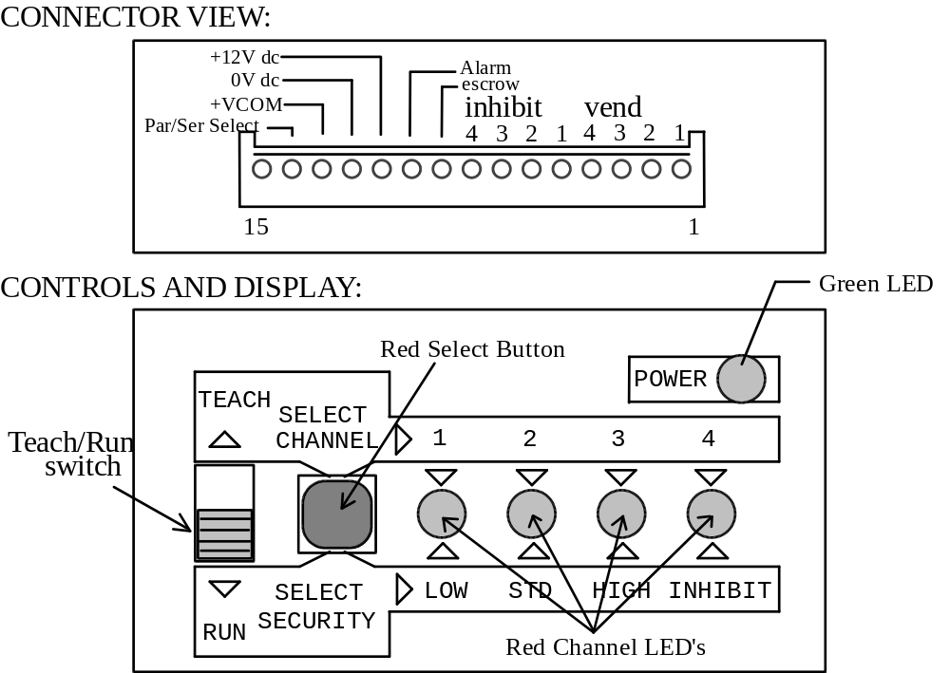

Normal Operation

Ready to accept notes:

Green Power light on
Red Channel LED’s off
Teach/Run switch in the RUN position

Accepting a note:

Green Power light on
Red channel LED’s. Appropriate channel light should flash on when note accepted.
Teach/Run switch in the RUN position

Rejecting a note:

Green Power light on
Red Channel LED’s off.
(If two or more lights flash it indicates confusion in identifying the note - no vend signal is given).
Teach/Run switch in the RUN position

For details of the operation during teaching see the chapter on teaching.
For details of indications during fault conditions see the chapter on fault finding.

General Description

Validator

The Smiley Bank Note Validator is a compact currency tester, suitable for most money machines. It will accept up to four different denominations of notes, inserted in any orientation with most currencies, and will cope with different designs of banknote having the same value such as are found in the United Kingdom or Spain.

The unit may be programmed using the built in Teaching facility, without requiring any additional equipment, to cope with new issues of notes or different currencies. New currencies and applications are being tested all the time, so please contact the factory for information concerning specific currencies if they are not already included on our approved list.

The validator is of small size and has been designed for easy installation in most machines. The unique “smiling mouth” allows insertion of notes with one hand and simplifies the note handling mechanism.

Interfacing of the validator is very simple, with the choice of parallel open collector outputs, a 300bps serial output, or a pulse stream output. A single 12V power supply required.

The principle of operation is that when a note is presented to the validator the front optical sensor activates the motor and electronics. As the note is drawn through the validator it is measured and examined with a variety of wavelengths of light along its length. The lens assembly enables the validator to examine the whole of the width of the note, while at the same time making the validation process insensitive to marks commonly found on many banknotes in circulation.

The characteristics of the note are then analysed to see if they fall within the characteristics of any of the notes that the validator has been taught to recognise, and if so, the note is accepted and the vend signal sent on the appropriate channel. Several techniques are implemented to detect forged notes and prevent the retrieval of notes already accepted. If any irregularities are encountered the note is immediately returned. In the unlikely event that a counterfeit note is found that the validator will accept, then it may be taught to recognise that note and reject it in future.

If the validation process confirms the note is genuine it will be passed through the validator and into the host machine. There is an anti-strimming device in the note path called a whale tail (from its shape). This device prevents the return of a note once the validator has accepted it. If the validator is used with a stacker unit then the whale tail is not needed and may be removed. This will improve performance with very thin or damaged notes. Other safeguards against strimming are also taken eg. checking for tape attached to the note etc.

Microprocessor technology is used to ensure high acceptance rates for genuine notes, and high sensitivity to forgeries. The unit is also designed so that there are no analogue controls, ensuring a long and stable operating life with no routine maintenance required.

Stacker

The function of the stacker is to take the notes from the back of the validator after they have been accepted and keep them safe and secure until the host machine is emptied. The stacker can be emptied on site or alternatively removed intact from the host machine, replaced with an empty unit, and the full one used to transport the notes to the cash office. During this time the stacker may remain sealed or locked until authorised personnel are available to release the notes.

The stacker may be mounted so that it can be released from the back or the front to allow for back or front access host machines. All power and control signals are provided via the validator through a simple telephone style plug. If the stacker becomes filled (about 175 notes) the validator is disabled until the stacker can be replaced or emptied.

Technical Description

Validator

Central to the operation of the validator is a microprocessor and associated RAM. The programmes running in the microprocessor control not only the note recognition but are also closely linked to the note transport system. Programme and note validation data is held in Flash EEPROM while the unit is powered down and immediately loads the RAM with all required data once the power is applied. It is useful to examine the memory structure of the validator. There is 64K Bytes of memory inside the Smiley Validator, 32K Bytes of Static RAM for normal operation, and 32K Bytes of 'Flash' Memory used to store taught note data and validation and control programmes.

RAM Usage:

256 Bytes are used to save note data whenever a note is read in. During manual teaching each note read in is saved temporarily in RAM. In this way a table is built up in memory. This table can contain a maximum of fifty note reads. If a fifty first note is entered into the Smiley, this data over writes the previous note that was read. When the Red Select Button is pressed OR the Teach/Run switch is slid to the Run position the table of notes is analysed to determine a definition of the note face. This definition is then saved in Flash memory for future validation tests. Further faces can then be taught, processed, and stored, either in the same channel if the value of the note is similar, or in a different channel for different values of note.

FLASH Usage:

The Smiley has four note channels. Each channel will normally store a different denomination note.
Each channel may contain up to ten faces.
Each note to be validated has four faces.
One face requires 512 Bytes of memory. In this way up to forty different faces may be recognised, split into four denominations.

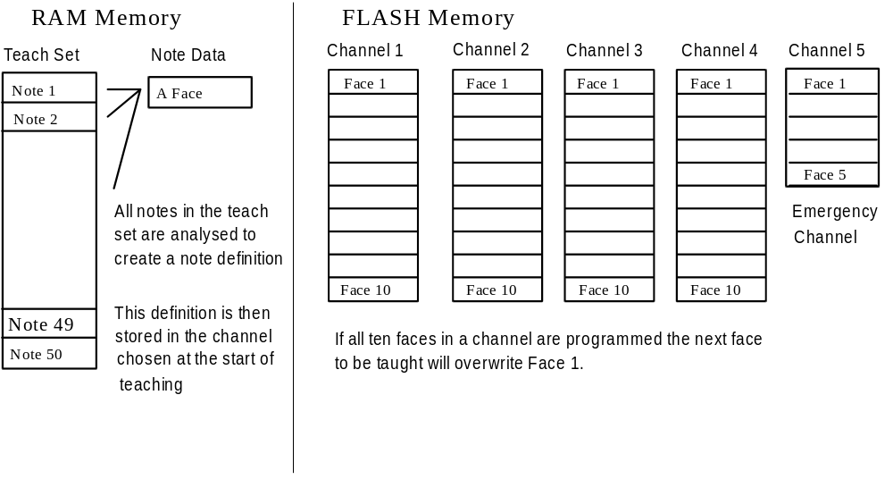
Channel 5 is an emergency channel that may be programmed with up to 6 faces of unacceptable or false notes that will always be rejected.

There is also a small general data table that is saved in Flash memory that maintains a record of how many faces there are in each channel, what is the next available face in a channel for note storage and other set up information about the condition of the light sources. This table is updated automatically whenever a new face is taught.

It is not recommended that the power supply be removed whilst note teaching is in progress. If power is lost during a Teaching session the note data currently being 'learned' will be lost.

Stacker

The power and control signals for the stacker are derived from the validator, and the only connection required is the cable supplied with the stacker. The stacker may be connected to either the top or the bottom socket of the validator using the adapter provided with the validator. The combined Validator and Stacker combination takes no more power than the validator on its own as the units only ever operate in sequence and never at the same time.

The mounting of the stacker should be arranged so that the flanges on the stacker fit either side of the validator. There may be a gap of up to 5mm between stacker and validator to allow for tolerances when fitting.

There is a red locking bar with three positions. When fully down the bar should penetrate the shelf supporting the stacker, preventing it being pushed backwards. In the middle position the bar locks the stacker to its base plate for removal from the host machine. In the up position the base plate separates from the body allowing removal of the notes. The locking bar may be secured or sealed to prevent the stacker being opened while still allowing it to be removed from the host machine.

The stacker in its normal configuration will accept notes of up to 155mm in length. If notes are expected that are longer than this then the stacker may be extended to cope with notes of up to 173mm. To do this remove the two screws securing the back of the validator to the case, undo the screw in each of the two red paddle shafts, and slide back the end of the stacker until it aligns with the second set of screw holes. Replace the screws in the case and red paddle shafts.

In normal operation the validator will push the note into the stacker and then cause the paddles of the validator to rotate. This ensures the note is pushed down into the stacker body. When the stacker is full the cam on one of the paddles will push on the pile of notes causing the paddle to lift. This causes a microswitch contact to close which is detected by the validator. To avoid false triggering the validator will wait until five closure contacts have been detected and then refuse to accept further notes.

Note that validators built before 18/12/94 require a modification before they will operate the stacker. Validators that can operate the stacker are identified by the letters S or QS below the serial number.

Environment and Power Requirements

Environment | Minimum | Maximum
Temperature | +5ºC | +35ºC
Humidity | 5% | 95% Non condensing

Do not use in Direct Sunlight

Electrical Supply | Minimum | Maximum
Supply Voltage (V dc) Absolute Limits | 11V | 15V
Supply Ripple Voltage | 0 | 0.25V @100Hz
VCOM (Host logic high) | 4V | 30V
Supply Currents
Standby |  | 120mA
Validating |  | 300mA
Stalled |  | 350mA
Peak (Motor start or stall) |  | 800mA

The connection of a stacker unit will add a negligible standby current, and the total peak current of the combined validator and stacker will not exceed the figures given above for the validator alone. (The stacker motor is only activated when the validator motor has stopped).

It is essential that the dc supply is sufficiently well regulated to cope with an 800mA surge and still remain at all times above 11V. If the voltage drops below 10V the outputs will be disabled, and there will be a 100ms delay before they are re-enabled after the power supply voltage is restored to specification.

Installation and Interfaces

Interface Logic levels | Logic Low | Logic High
Inputs | 0V < Low < 0.9V | +3.7V < High <(+VCOM+0.5V)
Outputs with 10KΩ pull up | 0.8V | pull up voltage of host interface

Note that the output low signal depends on the impedance of the pull up resistor on the host interface.

All outputs are open collector transistors with 120Ω in series.
All Inputs are held high to +VCOM via 10KΩ

Pin | Name: | Description:
1 | Vend 1 | Note accepted on Channel 1 pulse output (100milli secs)  Also the serial Output Pin in Serial Mode
2 | Vend 2 | Note accepted on Channel 2 pulse output
3 | Vend 3 | Note accepted on Channel 3 pulse output
4 | Vend 4 | Note accepted on Channel 4 pulse output
5 | Inhibit 1 | Inhibit channel 1 by holding this pin HIGH. To Enable a channel the inhibit must be held LOW.
6 | Inhibit 2 | Inhibit channel 2 by holding this pin HIGH
7 | Inhibit 3 | Inhibit channel 3 by holding this pin HIGH
8 | Inhibit 4 | Inhibit channel 4 by holding this pin HIGH
9 | Escrow | Operate Escrow function by holding LOW, refer to Escrow section for full details
10 | Alarm | Problem indication Output
11 | Supply Voltage
12 | 0V Supply
13 | +VCOM | Must be connected to the host machine interface supply voltage. See Circuit Outlines
14 | Parallel /Serial Select | Hold this pin HIGH for Parallel Pulse output. Connect this pin LOW for Serial Outputs.
15 | Factory Test Pin | FACTORY USE ONLY - DO NOT CONNECT

Connector Details:

15 Pin 0.1" pitch header, Molex 22-01-2155 (RS Components equivalent 479 - 175)

Fitting The Validator

To fit to a mounting panel follow the following steps:

1. Unplug and keep safe the short jumper lead linking top and bottom path assemblies.

2. Push up the red lock slides on each side of the validator.

3. Remove the upper path assembly (the part that includes all the controls and indicators) by pulling upwards and backwards.

4. Remove the top drawer assembly (this is the assembly behind the top plastic window) by depressing the catch and sliding it upwards.

5. Ensure the clamp at the bottom of the validator is free to move by fully sliding the red plastic ratchet to the side.

6. Insert the validator into the front of the panel, seating the lower edge of the cut-out in the open clamp at the base of the validator.

7. Push the validator flush with the panel and insert the top drawer assembly.

8. Looking from the back of the validator slide the red plastic ratchets top and bottom to the left until the validator is securely clamped in place.

9. Replace the upper path assembly and push down the red lock slides.

10. Replace the jumper lead.

Always mount the validator upright (+/- 20º) and never sideways or upside down.

Mounting Details

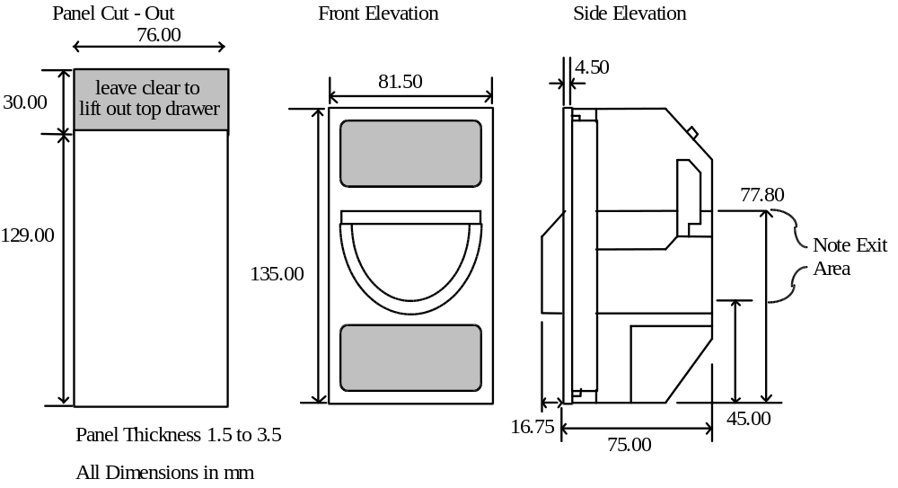

Input and Output Circuits:

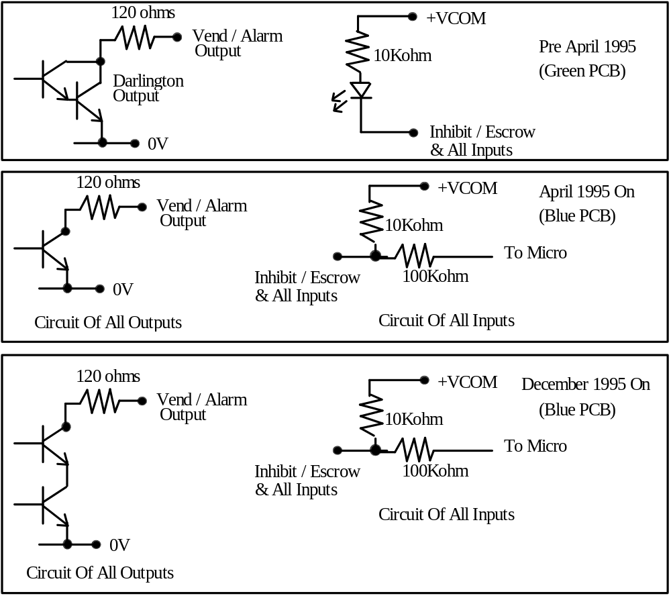

The Smiley provides either parallel or serial output if greater system security is required. All the inputs are always parallel. At present there is no facility for serial input.

Parallel Outputs:
To use parallel outputs pin 14 must be held high or left unconnected.
Vend Signals ( Pins 1 to 4). The four channels have their own individual outputs. If a note is recognised then the relevant channel line is pulled low for 100 + 5 milliseconds. It is recommended that pulses outside these limits are rejected as a precaution against false triggering due to noise.

Alarm Output: (Pin 10). This is a general purpose problem indication line. If a problem occurs then this signal will go low for 100milliseconds. The alarm signal will operate whenever one of the following conditions occurs:-

1) If the rear flag is raised when a note is not present
2) If a note is being returned to the customer and some how the note has become longer - i.e. strimming is being attempted.
3) If the stacker is full or a note is jammed in the validator.

Teaching and Security

Validators are normally supplied ready taught from the factory. This section may be skipped unless the validators need to be re-taught a new note or currency. If you re-teach it is recommended that the old channel information is erased first, otherwise it will remain in the memory as a permitted face.

We recommend to use the available PC download facilities. For further information please contact Innovative Technology.

Erasing a Channel

If the validator has already been taught a new currency, reteaching it will not make it forget the old . In this case it is important to delete the old information in each channel. To erase a channel slide the Teach/Run switch to Teach. Select the channel to be erased by repeatedly pressing the select button. Now press and hold down the select button until the selected channel light goes off and comes back on. This will take approximately six seconds. If further channels need to be erased press the Red Select Button repeatedly until the correct channel is selected and then hold down the button as previously described. It is not possible to reverse the erase process!

Teaching

Before teaching the validator examine the list of approved currencies in the appendix. Some currencies are only approved to be taught on particular faces for security reasons. Currencies not on the list have not been subject to the same (if any) levels of testing as the approved currencies. Users should take particular care to satisfy themselves on the security of operation once the validator has been taught.

For teaching the validator must be powered up, VCOM must be present, and the Inhibit signals must be held LOW.

You will require at least fifteen examples of the new note, and preferably twenty (some currencies may require more, particularly if there is more than one organisation printing the notes). Teach note selection is very important to obtain a good acceptance rate. As a guide your teach notes should contain at least five new notes, the rest should be 'typical' notes that are in circulation.

The following notes should not be used for teaching:-

Do not use very old or soiled notes for teaching.
notes that have parts missing or large tears in them.
notes that have been repaired with any kind of adhesive tape.
notes with corners folded over

Sort the Teach notes so that they are all the same way up and the same way around. Do not mix different designs of the same denomination e.g. English and Scottish notes. They should be taught as separate faces in the same channel

Remember that the quality of teaching notes will affect the accept rate of notes. A well taught unit will have a very high acceptance rate.
Selecting a Channel

Locate the slide switch marked TEACH/RUN
Locate the Push button marked SELECT CHANNEL/SELECT SECURITY
Locate the four channel LED's marked 1 to 4
Ensure that the Green Power On light is illuminated

The Smiley can accept up to four different denomination of notes, i.e. £5, £10, £20, £50
For this exercise we will assume that a new £50 has been introduced. Normally the unit is pretaught with the lowest denomination in channel 1, the others in ascending order. So a £50 will be recognised as channel 4. We wish to teach the new £50 alongside the old £50 in channel 4.

Slide the Teach/Run switch up to the teach position
Repeatedly press the red Select Channel button until the channel 4 LED is ON.

Insert the teach notes into the Smiley, one after the other. Wait until one note has left the unit before trying to insert the next note. Insert the notes reasonably straight and central.
Do not deliberately insert notes that go up the sides of the note path or are badly twisted. Make sure that none of the teach notes have corners or edges folded over. This may unnecessarily distort the note definition and reduce the effectiveness of the Smiley.

Re insert the teach notes in this same orientation at least twice. When you have done this press the Select Button. The channel LED will blink once to confirm that the note data has been stored. If other faces of this note need to be recognised, change the orientation of the teach notes and insert the notes in the manner just described. Remember to press the Select button at the end of each face taught.

When you have taught the desired faces of the note, slide the Teach/Run switch to the RUN position. The channel lights will now indicate the security setting for the channel you have just taught, and after five seconds the LED will flash four times indicating teaching is completed. If you need to change the security settings see the next section which explains the process.

Note: While teach notes are being inserted the Smiley performs a very elementary test to look for operator errors. The Smiley checks the length of the notes and also does a crude test to see if subsequent notes are similar to the first teach note that was inserted. This is not fool-proof, its effectiveness may depend upon the currency being taught.
If the Smiley sees a note that it does not believe to be sufficiently similar it will flash all the channel lights momentarily and ignore the note for teaching purposes. If notes are inserted too quickly the channel lights will flash momentarily and the note data rejected. (Early units returned the problem note back to the operator).

For most currency sets this method will give good results. For some currencies you may notice that the four LEDs flash frequently when teaching. This is because certain batches of notes may have very different characteristics, and in these cases it causes the validator to reject them as not belonging to the same set as the first teach note. This can be for many reasons, but one common one is a change in characteristics as the notes age. If this is seen to be happening when teaching an alternative method can be used that will improve acceptance rates.

Sort the notes into two sets, one with new and little used notes, the other with old and worn notes. Teach the sets into the same channel, but as different faces. This will result in twice as many faces being taught into a channel, but will give better acceptance rates due to the validator not rejecting notes during teaching.

Security Levels

The Smiley has three security level options. The security levels affect the severity of note testing and may be independently set for each of the four channels. The higher the level of security the more closely the validation is examined. The security levels may be checked and changed if necessary whenever the validator is switched from a selected channel in Teach mode to Run mode. When the switch is slid from Teach to Run one of the four Red LED’s will light, indicating the current security level for the channel that has just been taught. The indications are:

LED 1 Security level one (lowest security).
LED 2 Security level two (recommended for most applications).
LED 3 Security level three (highest security).
LED 4 Inhibit. No notes will be accepted on this channel.

If the Red Select Button is pressed after the validator has been switched from Teach mode into Run mode then the LED’s will be seen to light in turn. Leave the light on that indicates the level you want applied. This must be done within 5 seconds of the unit being switched into Run. The light selected will then flash four times to indicate the operation is complete. It is not necessary to re-teach the validator to change the security levels - just go into teach mode, select the channel required, switch to Run and reselect the security level.

Channel Five (Emergency Channel) Teaching

When selecting the channel to be taught it will be observed that the selection after channel four makes all the red lights come on. This is channel five and it is for emergency use only. Channel five is used for teaching the validator to recognise and reject any new fraud that the validator has previously not been able to detect. Channel five is always checked first by the validator to see if a presented note has a match there. This is a short term solution, and the factory should be informed of the circumstances as soon as possible.

The only operating difference with channel 5 is that the security levels work in reverse. The lower the security setting on channel 5 the more likely the Smiley is to recognise the note and reject it.

Code Lock

Validators produced since October 1995 (Serial number 0102000) have the capability for a three digit code lock to be activated, preventing unauthorised teaching of the validator. If you do not have the code lock facility activated and do not wish to use it you may skip the Code Lock sections.

Code Lock Activation

To activate the code lock perform the following sequence:

1. Ensure the Teach/Run switch is in the Run position.

2. Hold down the Red Select Button and switch the slider to Teach.
All Red LED’s should flash twice.
You now have 60 seconds to complete this operation.

3. Press the Red Select Button repeatedly until the Red LED’s show the first digit of the three digit code. Note the digits are presented in binary - see below for an explanation.

4. Slide the switch from Teach to Run and back to Teach.

5. Press the Red Select Button repeatedly to select the second digit.

6. Slide the switch from Teach to Run and back to Teach.

7. Press the Red Select Button to select the third and final digit.

8. Slide the switch from Teach to Run and back to Teach.
All Red LED’s should flash once.

9. Slide the switch to Run.
All Red LED’s should flash once.
The validator is now code locked.
The code locking cannot be removed except by returning the validator to the factory.

Note: Binary notation is the expressing of numbers as a pattern of “1” and “0”. On the Smiley validator the code numbers are in binary as shown by the Red LED’s.

Digit LED 1 LED 2 LED 3 LED 4

1 ON OFF OFF OFF
2 OFF ON OFF OFF
3 ON ON OFF OFF
4 OFF OFF ON OFF
5 ON OFF ON OFF
6 OFF ON ON OFF
7 ON ON ON OFF
8 OFF OFF OFF ON
9 ON OFF OFF ON
Code Lock Opening

Your unit may have a code lock fitted and already activated. If so, when Teach is selected and the Red Select Button is pressed repeatedly the Red LED’s will be seen to be counting up in binary notation. To teach a code locked validator :

1. Select Teach

2. Press the Red Select Button repeatedly until the first digit shows on the Red LED’s.

3. Slide the switch from Teach to Run and back to Teach.

4. Press the Red Select Button repeatedly until the second digit shows on the Red LED’s.

5. Slide the switch from Teach to Run and back to Teach.

6. Press the Red Select Button repeatedly until the third and final digit shows on the Red LED’s.

7. Slide the switch from Teach to Run and back to Teach.
All Red LED’s will flash twice.
Leave the switch in the teach position. You will now be able to select a channel and teach.

Code Lock Changing

To change the code:

1. Ensure the Teach/Run switch is in the Run position.

2. Hold down the Red Select Button and switch the slider to Teach.
All Red LED’s should light once.

3. Press the Red Select Button repeatedly until the Red LED’s show the first digit of the code.

4. Slide the switch from Teach to Run and back to Teach.

5. Enter the remaining digits of the existing code in the same way.
All Red LED’s should flash once.

6. Continue and enter the new code.
The LED’s should flash once.

7. Enter the new code again.
The LED’s should flash twice.
The unit will now be in teach mode and may be re-taught, or switched to Run

Operation

This assumes the validator has been pre-taught and that Escrow is not in use.

Quick Check
Ensure that the Green Power On led is illuminated and that there is at least +12v DC available.
Check that the short jumper lead is connected at the top and the bottom
Ensure that the relevant inhibit inputs are held LOW
Ensure that the +VCOM pin is connected to a voltage in the range +5 to +30 V dc
Ensure that the TEACH/ RUN switch is in the RUN position

Insert a note of the taught currency. The Smiley accepts notes when the note is presented reasonably straight and central. The note is scanned using a unique patented system of optical sensors that view the entire width of the note and store the data in memory. Once the note has been scanned a comparison algorithm is used to determine if the just read note "matches" any of the note descriptions stored in memory.

If the note is recognised it will be pushed out of the rear of the unit. A vend output will be produced when the note has completely left the validator. Whilst the vend output is being issued the corresponding channel light will be displayed.

If the note is returned this will be either:

a) the note was not recognised as valid or
b) one of the security devices was activated or
c) the channel has been inhibited, either locally by setting the security to level 4, or by the host holding the inhibit inputs high.

For pin connections and signal descriptions see the Installation and Interfaces section.

Serial Outputs:

The serial output is from pin 1, and is enabled by connecting pin 14 to the 0v supply. There are no “handshaking” connections. Inhibits and escrow are still parallel as normal.

The serial information is transmitted as follows:-
1 start bit (logic low (0v))
8 data bits ( least significant bit first)
2 stop bits (logic high (+VCOM))
Baud rate = 300 bits per second ( fixed)

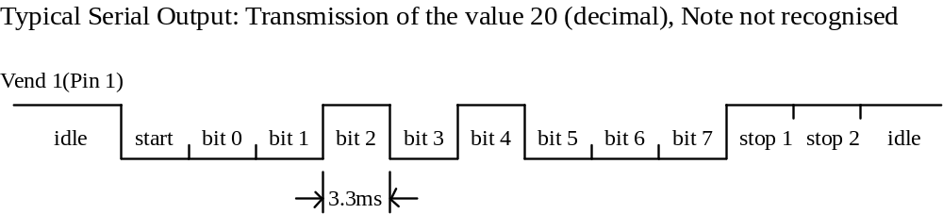

Codes that may be transmitted are as follows:

MESSAGE: | DECIMAL VALUE
Accept on channel 1 | 1
Accept on channel 2 | 2
Accept on channel 3 | 3
Accept on channel 4 | 4
Note not recognised | 20
Mechanism running slow | 30
Strimming attempted | 40
Recognition of channel 5 face | 50
Stacker Full or Jammed | 60
Abort During Escrow | 70
Note may have been taken to clear jam | 80

Please note that this format is RS232-TTL. If 'true' RS 232 is required then the signal on Pin 1 may be connected into a MAX 232 converter IC directly.

Pulse Output:

In pulse output mode a series of pulses is generated on the Vend 1 output pin. It is possible to specify the number of pulses required for each channel and also the pulse period to be used for all channels.

Inhibits and Escrow

Escrow

The Smiley has a single note escrow facility. This allows the validator to hold onto the note once accepted, and then only pass the note out of the back of the validator when the host machine confirms that the Vend operation has been completed. If no confirmation of the Vend is received then the note will be returned to the customer after 30 seconds. If the host machine itself aborts the transaction by raising the inhibit input high, the note is returned immediately. The sequence of operations is as follows:

1. Pin 9 held low awaiting note insertion.

2. Note inserted. Validator issues a 100ms pulse on appropriate channel.

3. The host machine initiates vend process.

4. The host machine raises pin 9 high to indicate that it wants the note. If this is not done within 30 seconds the validator will return the note.

5. The validator issues a 100ms pulse on the appropriate channel within 3 seconds of pin 9 going high to indicate final acceptance of the note. (If the signal has not been received within 3 seconds it indicates the customer has forcibly retrieved the note and the vend should be aborted.)

6. The vend process is completed.

7. The host machine makes pin 9 low in expectation of the next vend.

The host can , at any time before the end of the 30 second timeout, force the return of the note to the customer by raising the inhibit line high (only on validators produced after October 1994).

Inhibits and the escrow inputs are always parallel in operation.

Please note that the inhibits will not work correctly unless +VCOM is connected to the host machine interface logic high supply voltage.

If the validator is in serial mode with a note held in Escrow and a second note is inserted the validator will send the serial message Abort During Escrow (70).

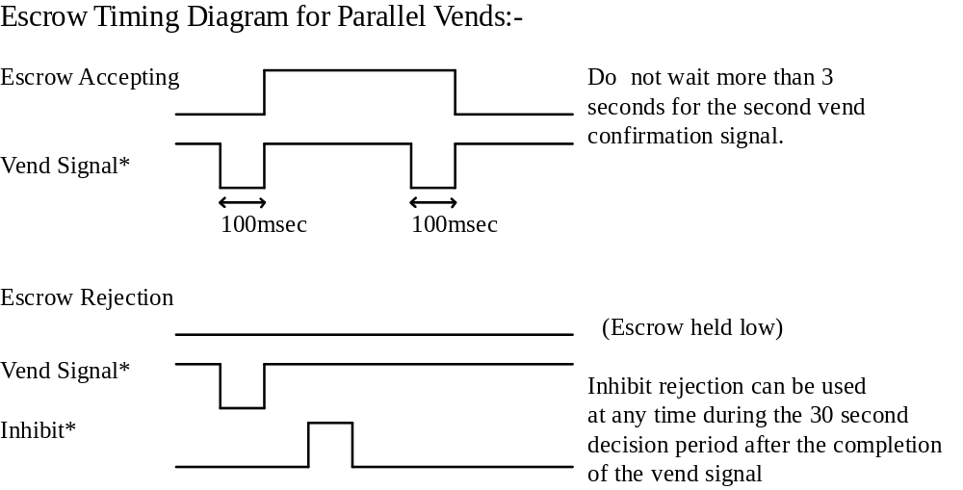

Inhibit Operation

Each channel has its own inhibit input to allow the host machine to refuse specified values of notes. To inhibit a channel the relevant inhibit input must be held high. The inhibit may be selected at any time - even whilst a note is being read in. To enable a channel the corresponding inhibit must be latched low so that notes may be accepted.

If all four inhibits are high simultaneously then the Smiley will not read in any notes. The motor will run in reverse preventing the insertion of a note. All four inhibits may be connected together to create a 'global' inhibit. In this way the Smiley may be brought in and out of operation by the host machine.

It is also possible to inhibit channels directly on the validator by selecting security level 4. This inhibit cannot be overridden by the host. See the section on Teaching / Security for an explanation of this inhibit facility.

Routine Maintenance

Routine maintenance is advised every 10,000 notes or six months, whichever occurs first. At this time do the following:

1. Remove the upper path assembly as described in the installation instructions.

2. Inspect the note path inside the validator for damage or abuse.

3. Remove any debris and dust with a soft brush and damp cloth. Take care not to bend the whale tail.
Do not use solvents or abrasives for cleaning.

4. Inspect the rubber drive tyres for wear and replace if necessary.

5. Re-assemble and test. Check that the progress of the note through the validator is smooth.
(There will normally be a hesitation before the note is finally accepted as verification is completed).
Do not lubricate any components.

Fault Finding

The Smiley Validator has been designed for long life with minimal maintenance. As far as possible the circuit avoids the use of potentiometers to remove setting up operations and drift. The units are initialised at the factory but this should not have to be repeated.

The light sources used inside the Smiley do age but owing to the way in which they are used this would take an extremely long time before it would affect the unit. The LED's used in the scanning system age to 50% of original intensity in 105 hours. (100000 hours). (Data from Siemens Semiconductor Group). When a note is read the sources are only in use for typically 120 milliseconds in total each. At this rate of usage a 5% deterioration in light source intensity would require more than 1 million notes to be read.

The mechanical components too have been optimised to simplify the mechanics as much as possible. All rotating parts are moulded from polyacetal. This is a low friction material that requires no lubrication, and none should ever be applied

The tyre compounds used have been selected for use in oxygenated atmospheres. (many synthetic rubbers breakdown rapidly in air - do not replace the tyres with neoprene grommets or 'O' rings).

If a foreign substance is introduced into the note path (i.e. ketchup or beer) then the areas affected should be wiped clean with a damp cloth and a small amount of detergent. DO NOT use any solvents (including alcohol) to clean the Smiley Validator as they may attack the plastic parts over time.

Any individual component or subassembly may be obtained from the factory in the event of a repair being required, and diagrams are included at the end of this manual to help with identification of components and opening the unit.

Problem Solving Suggestions

Problem | Check: | Solution
Validator will not take notes: | Is the Green power light ON? | Check power supply
 | Is the jumper cable connected from the top to the bottom of the validator? | Test cable
 | Is the Teach Run switch in Run?
Validator runs slowly or intermittently: | Check that the spring steel "whale tail" is not damaged. | Replace whale tail if necessary
 | Make sure there are no foreign objects in the note path | Clean the note path
 | Ensure there is no grease on Opto wheel tyre | Replace opto wheel tyre
Notes pass through the validator but do not give a vend signal | Is the unit in TEACH mode? - check the Teach/Run switch  Is the power supply inside specification.  Is the rear flag stuck up. | Make sure the validator is in run mode.  Ensure correct supply and sufficient current..  Make sure rear flag moves freely
Validator may be taught notes but will then not accept any note. | Check that +VCOM is connected to your interface supply voltage (+5v to +12v) | Test interface connections.
 | Check that the relevant inhibits are disabled ( to enable a channel). The inhibit pin should be held logic low (0v). | Test interface
 | Check that ESCROW is off. | Test Interface
Unit rejects genuine notes | Check that the unit has been taught this face. | Teach the note
 | Check the channel security setting | Adjust security setting
Unit confuses notes |  | Erase the affected note channels and re-teach the notes. Insert notes central and straight for the best results.
Validator is difficult to teach. | Check all teach notes are in the same orientation. | Sort notes prior to teaching
 | Check teach notes are not badly damaged or heavily stained | Change the teach notes for ones that are in better condition.

Appendix A - Glossary

Escrow:
A legal term referring to the temporary holding of funds in a safe independent place.
Used to refer to the operation where the validator holds the note for acceptance or return until the vend operation is complete.

Face:
The printed surface of a note scanned in one direction.
Each side of a note has two faces, each note has four faces.
e.g. a £5 has the following faces:
1) Queens face up and first
2) Queens face up and last
3) Queens face down and first
4) Queens face down and last

Host:
The equipment that contains the note validator e.g. gaming or vending machine.

Inhibit:
The signal that prevents note acceptance on any or all channels.

Note:
A paper or plastic unit of currency.

Teaching:
The process which allows the validator to learn to recognise a new face of a note.

+VCOM:
The logic high level of the host machine.
It is independent of the validator supply voltage and must be connected.

Vend:
The process where the host machine dispenses the services or goods paid for.

Appendix B - Parts Lists

Field Replaceable Parts

The following list of parts are those that a service engineer may reasonably expect to be able to replace without returning the unit to the factory. They are items that are exposed to the public or are liable to mechanical wear during normal operation.

Part Number | Description
DB33 | Toothed Drive Belt
FT34 | Front Tyre (Black)
OWT38 | Opto Wheel Tyre
RT35 | Rear Tyre (Red)
CL48 | Currency Label
DW2 | Display Bezel (Window)
FP1 | Front Plate Moulding (Polycarbonate)
IL49 | Information Label

Complete Parts List
